Cybersecurity-task-1--Network-port-Scan
Cybersecurity Internship Task 1 - Local Network Port Scanning using Nmap
Name: [Your Name] Date: 5 November 2026
OBJECTIVE
To scan the local network for open ports and understand the risks they can cause.
TOOLS USED
Nmap 7.993, Windows Command Prompt and Wireshark.
NETWORK INFORMATION
I scanned the range 192.168.136.0/24, which looks like a VMware network. The scan type was a TCP SYN scan.
COMMAND USED
nmap -sS -oN scan_results.txt 192.168.136.0/24
SCAN RESULTS
2 hosts were up out of 256 addresses.
Host 1: 192.168.136.254
All 1000 ports were filtered, so no open ports were found.
Host 2: 192.168.136.1
7 ports were open: 135 (msrpc), 139 (netbios-ssn), 445 (microsoft-ds), 902 (iss-realsecure), 912 (apex-mesh), 4343 (unicall) and 4449 (privatewire).
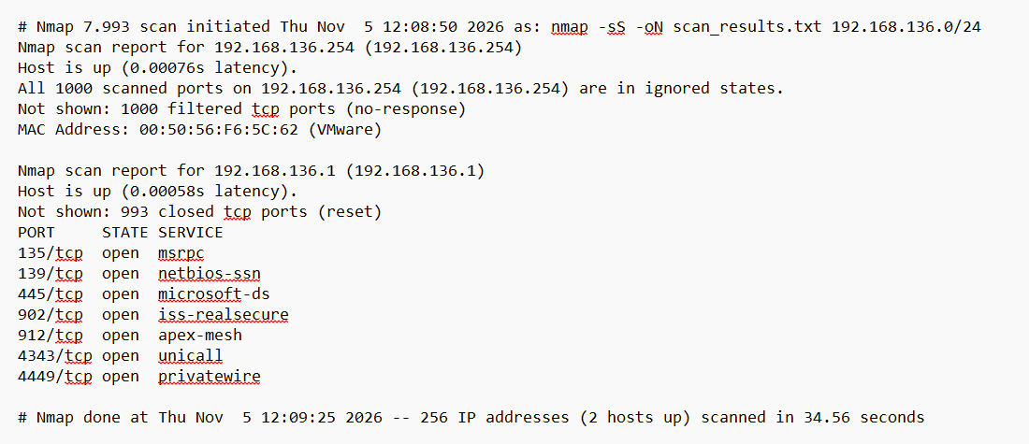
SERVICES ON THE OPEN PORTS
Port 135 is the Windows RPC service, port 139 is old Windows file sharing (NetBIOS) and port 445 is SMB, which is also Windows file sharing. Ports 902 and 912 are usually the VMware authentication service. I could not identify ports 4343 and 4449, and the names Nmap shows for them are only guesses.
SECURITY OBSERVATIONS
Ports 135, 139 and 445 are Windows networking ports and should be kept secure. Port 445 (SMB) is the riskiest because worms and ransomware have used it. Ports 902 and 912 are VMware services and should only be used locally, and ports 4343 and 4449 are unknown, so they should be checked.
An open port is not always a vulnerability. It depends on the service and its settings. To reduce the risk, close unused services, keep software updated and use the firewall.
WIRESHARK ANALYSIS
I captured a SYN scan in Wireshark using the loopback adapter, and ran this command as administrator:
nmap -sS -p 135,445,8080 127.0.0.1
I saved the capture as nmap_syn_scan.pcapng and read it with display filters. I used tcp.flags.syn==1 && tcp.flags.ack==0 for the SYN packets, tcp.flags.syn==1 && tcp.flags.ack==1 for the SYN/ACK replies, tcp.flags.reset==1 for the RST packets and tcp.port==51132 for the full scan, since Nmap used source port 51132.
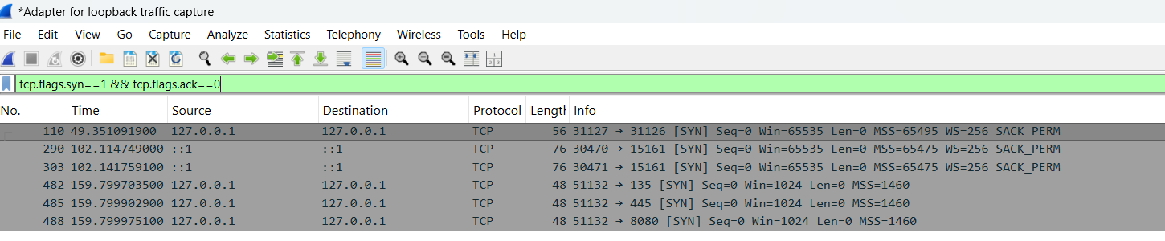
Nmap sent a SYN to ports 135, 445 and 8080. The other rows are background traffic.
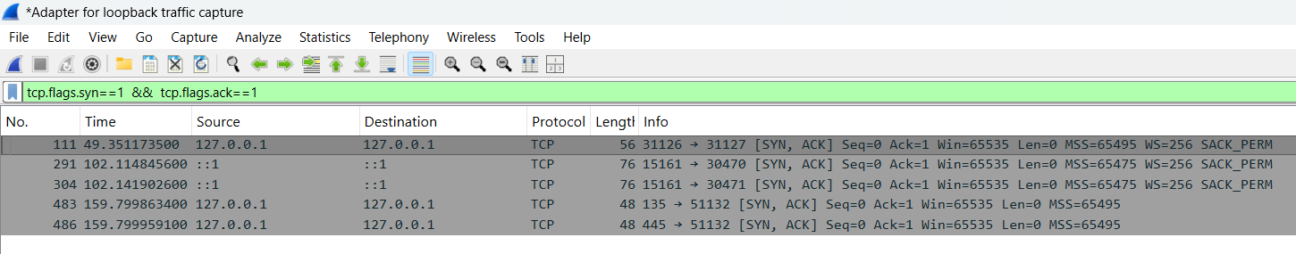
Ports 135 and 445 replied with SYN/ACK, so they are open.
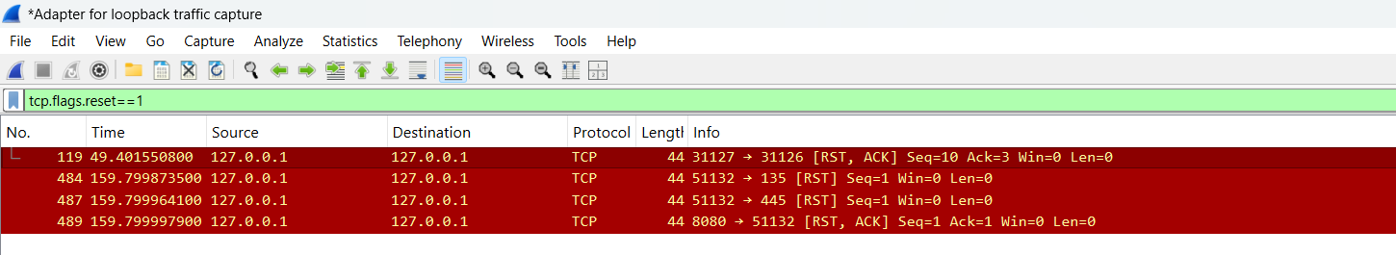
Nmap sent RST after each SYN/ACK. Port 8080 replied with RST/ACK, so it is closed. Packet 119 is not part of the scan.
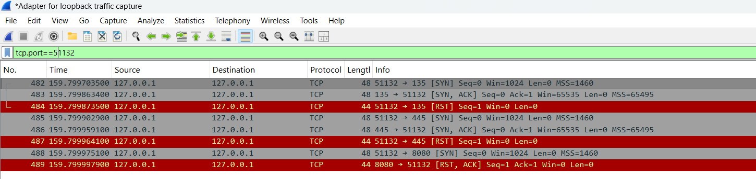
In the full scan, ports 135 and 445 showed SYN, SYN/ACK and RST, so they are open. Port 8080 showed SYN and RST/ACK, so it is closed. Ports 135 and 445 were also open in the main scan, so the results match.
CONCLUSION
This task gave me practice in scanning a network, finding open ports and understanding service exposure. Wireshark showed how a SYN scan works: open ports reply with SYN/ACK and closed ports reply with RST.
EVIDENCE
The repository contains scan_results.txt, nmap_scan_results.png, nmap_syn_scan.pcapng, the four Wireshark screenshots (wireshark_syn_probes.png, wireshark_open_ports.png, wireshark_rst_replies.png and wireshark_full_exchange.png) and README.md.

